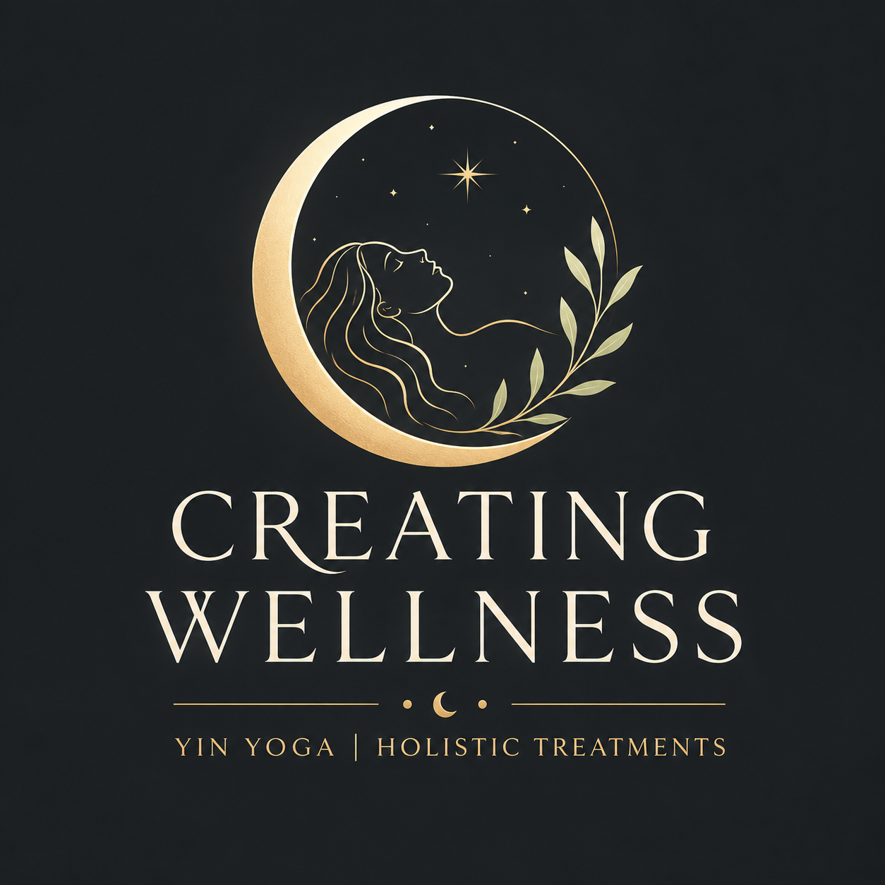
TRIGGER POINT MASSAGE
Client Information Guide
A focused manual therapy approach for persistent muscular tightness, tenderness and referred discomfort.
Creating Wellness | Southsea, Portsmouth

What is Trigger Point Therapy Massage?
Trigger Point Massage is a focused form of manual therapy used to work with specific areas of muscular tenderness, tightness and restricted movement. Rather than providing a general full body massage, the treatment concentrates on the muscles most closely related with the client’s symptoms. These tend to be muscles in the back, shoulders, hips or neck. This treatment is particularly suited to persistent knots, localised muscular pain, recurring tightness and areas that feel restricted despite general massage, stretching or rest.
The therapist uses careful assessment to identify sensitive areas within the muscle. Controlled pressure is applied using the thumbs, fingers, knuckles or a wooden Thai massage stick where appropriate. The pressure is always adjusted to the individual. Trigger point release techniques may reduce tenderness and improve pain sensitivity or movement particularly in the short term.

What is a trigger point?
A trigger point is commonly described as a highly sensitive spot within a taut band of skeletal muscle. Trigger points are often described as knots, lumps or tight bands. Trigger points can be extremely painful, limiting your range of motion and making it difficult to do your daily activities.
They are parts of the muscle that have spasmed or "cramped". The spasm causes the muscle to tighten and become rigid, which in turn reduces blood flow causing a build-up of waste products and reduced nutrients to that area. That build-up of waste becomes toxic causing the spasm to increase. This process goes around and around in circles which causes the lumps to continue to grow, creating intense radiating pain.
Pressure on the area may reproduce familiar local discomfort or create referred discomfort in another area of the body. For example, a sensitive point in the upper back may be felt around the shoulder, neck or head rather than only at the point being pressed.

What can contribute to trigger point sensitivity?
Trigger point sensitivity can develop for more than one reason. Common contributing factors include:
• Prolonged or repeated positions, such as desk work, driving or looking down at a phone.
• Repetitive movement, heavy physical work or unaccustomed exercise.
• A sudden muscular overload or strain.
• Reduced movement variety and long periods of inactivity.
• Stress, poor sleep or limited recovery, which can increase muscle guarding and pain sensitivity.

What Happens During the Treatment
1. Consultation and assessment
The session begins with a discussion about your symptoms, health history, daily activities and what you would like the treatment to achieve. The therapist will assess the neck, back, shoulders or hips to pinpoint areas to be treated.
2. Locating sensitive areas (knots)
The therapist locates hyperirritable spots (trigger points) in skeletal muscle fibres or surrounding fascia.
3. Applying controlled pressure
Direct, sustained pressure is applied to the chosen area for 60 to 90 seconds. Depending on the location, this may be delivered with the thumbs, fingers, knuckles or a wooden Thai massage stick. Pressure is increased gradually and adjusted throughout the treatment.
4. Breathing and reducing muscle guarding
You will be expected to carry out slow, steady breathing to help you remain relaxed and reduce the tendency to brace against pressure and stimulate the parasympathetic nervous system, restoring blood flow, pain relief and nutrients to that area.
5. Reassessment
After the pressure is released, the therapist may reassess tenderness, movement or the way the area feels. The process may be repeated in the same area or on related muscles where this is relevant to your symptoms.

Potential benefits
Depending on the individual and the cause of the symptoms, Trigger Point Massage may help to:
- Reduce local muscular tenderness and the feeling of persistent knots.
- Ease stiffness and improve comfort during everyday movement.
- Increases your overall range of motion and flexibility.
- Reduces referred muscular discomfort in related areas.
- Increase awareness of patterns linked to work, posture, exercise or stress.

Areas that can be treated
At Creating Wellness, this treatment can focus on one or two areas during the appointment:
- Neck
- Upper back
- Middle back
- Lower back
- Hips

The area that feels painful is not always the only area assessed. Muscular discomfort can be referred, and nearby muscles may be contributing to the same pattern.

Frequency of Treatments
Appointments are available for 30, 45 or 60 minutes. A shorter session is suitable for one clearly defined area. A longer appointment allows more time to assess and treat one or two connected areas.
For acute conditions, your therapist might recommend 2-3 sessions weekly for the first couple of weeks, then gradually decreasing frequency as your condition improves. Chronic conditions typically respond best to consistent weekly sessions until significant improvement occurs, followed by maintenance sessions every 4 weeks.
There is no single treatment frequency that is right for everyone. Some people notice a change after one appointment, while persistent symptoms may benefit from a short series of sessions alongside movement, stretching, strengthening or ergonomic changes.

Post Treatment
After your session, you might experience a variety of normal responses. Temporary soreness for 24-48 hours is common, similar to the feeling after a good workout and should dissipate within a day or two. Many clients report immediate pain relief, improved range of motion, and a sense of lightness or ease in the treated areas. Some experience fatigue as the body processes the metabolic waste released from trigger points, while others feel energized as pain-induced tension lifts. Occasionally, emotional releases occur during or after treatment as physical tension connected to emotional stress dissolves.
Aftercare is simple:
- Continue with normal hydration.
- Choose gentle movement, such as a short walk, and follow any stretches or exercises recommended for you.
- Avoid unusually strenuous activity if the treated area feels tender.
- Notice how the area responds over the following day or two and share this at your next appointment.

Creating Wellness provides this treatment as a supportive manual therapy for muscular tension and discomfort. No guarantee of pain relief can be made, and treatment is not a replacement for assessment by a GP, physiotherapist or other regulated healthcare professional when symptoms are persistent, worsening, unexplained or neurological.

Creating Wellness | Yin Yoga and Holistic Treatments | Southsea, Portsmouth

